Working in the Cloud

with ClearMedia Academy

ClearMedia F-Secure deployment

**Disclaimer**:

By using the ClearMedia vCloud Director templates, you can greatly reduce the amount of time needed to deploy new VMs. These templates have been configured with the best practices in mind, to assure optimal stability and performance. Although use of the template is not compulsory, it is recommended!

This guide assumes you are building a new vApp based on Template version 1.4 and deploying the template from the “Catalog” tab with a single server setup or “All-In-One” (AIO) server.

In-Depth explanation and step-by-step procedures

* Request the F-Secure “Email and RDS Server” license via the ClearMedia support.
* Request a key for x users, corresponding to the number of RDS users and mentioning the vApp name.
* If you do not have an account on the ClearMedia F-Secure PSB portal (the place where the servers and licenses are managed by the partner), you will receive instructions from the ClearMedia support to register this.
* Once registered, open the registration email which contains the credentials that you need to login to the F-Secure PSB portal.
* Login to the portal at <https://emea2.psb.f-secure.com/> and go to the Download tab.
* Find “Server Security | Email and Server Security” on the Download page.
* Download the Windows version by clicking on the blue button “EXE” button.

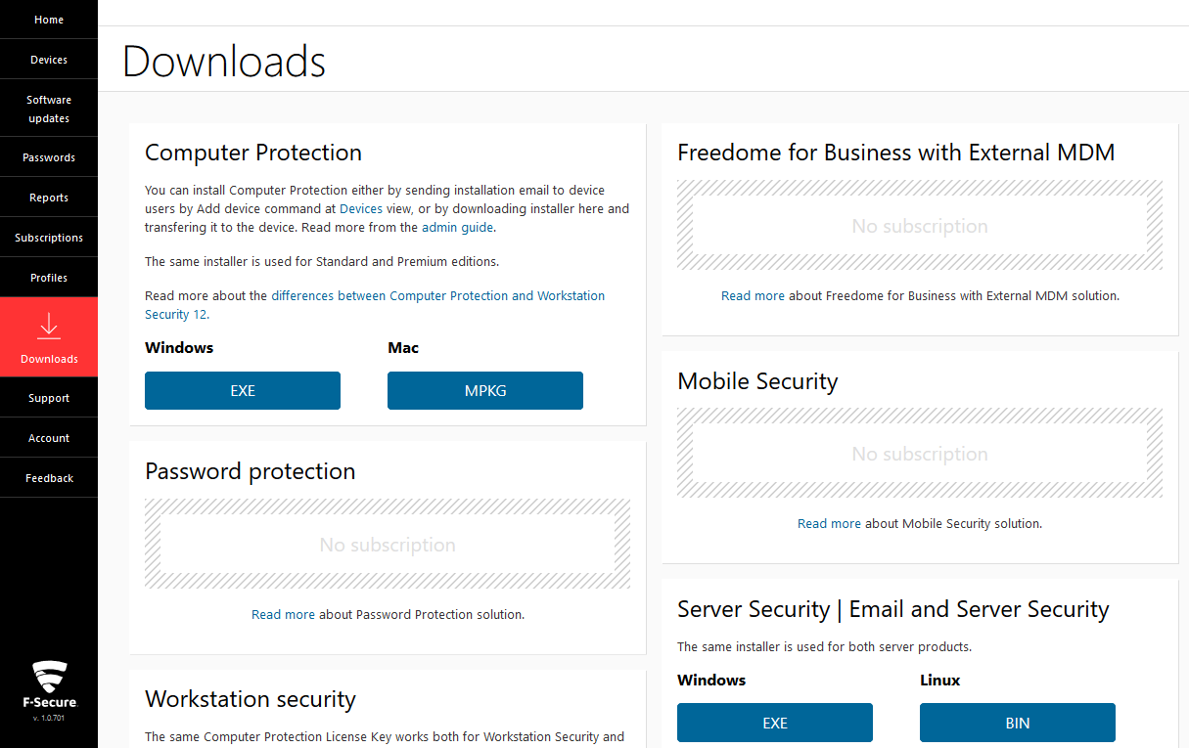

* Install the software on the server.
* At a certain point it will ask for a subscription key.
* Go back to the PSB portal and click on the “Subscription” tab, on the left ribbon.

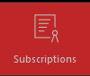

* Look for the customer in your list and open it by clicking on the chevrons.
* Copy paste the key that you can find under “Subscription key” to your F-Secure install wizard.

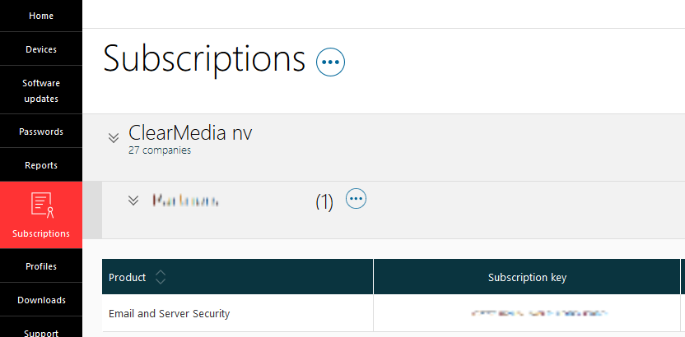

* Finish the installation of the F-Secure agent on the server.
* After completion reboot the server.
* To manage the F-Secure agent locally, open the F-Secure admin web-interface via the Start Menu or by pasting the link in the browser: <https://127.0.0.1:25023/authok.htm> .

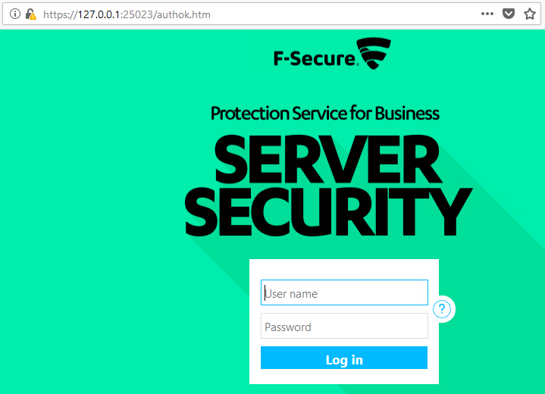

* Logon with credentials that have local admin rights.
* Edit the Scanning Exclusion list by going to “Server Protection”, then “Real-Time Scanning” and then clicking on “Configure” behind “Exclude from Scanning”.

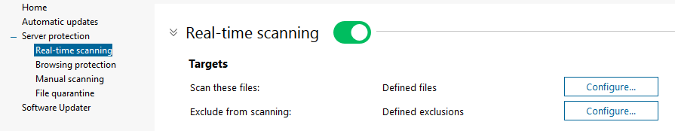

* Go to the “Objects” tab and click on “Add”. Either browse to a folder or add the folder by copy pasting it in the box above. Click on “OK” twice **AND** on “Save to Apply” below to actually save the settings.

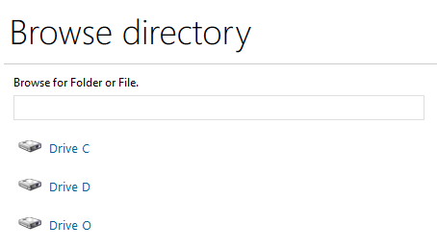

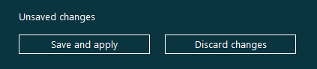

* You can also configure the policy’s via the online PSB portal. You can find this under “Profiles”.



* Finished!